**Heap Data Structures: Implementation, Analysis, and Applications**

Venkata Manasa Kakarla

Student ID: 005027517

Algorithms and Data Structures (MSCS532-A04)

Assignment - 04

Heap sort Implementation and Analysis

1. Implementation:

Python program for heap sort algorithm with clear, efficient, the correct steps for building a max-heap, extracting the maximum element, and maintaining the heap property.

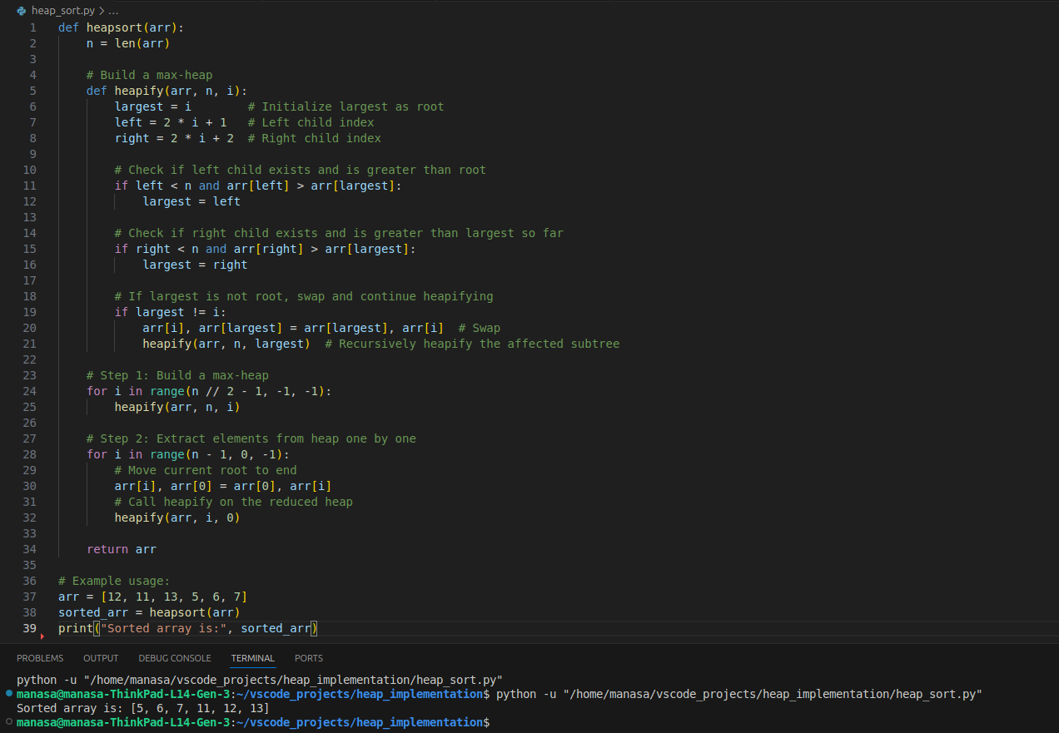

1. Analysis of implementation:

Heapsort is a comparison-based sorting algorithm that leverages the properties of a binary heap to sort an array. Here is a rigorous analysis of its time complexity in the worst, average, and best cases.

**1. Building the Max-Heap:**

Time Complexity Analysis:

* Heapify Operation: The heapify operation ensures that a subtree rooted at a given index maintains the heap property. This operation has a time complexity of O(logk), where k is the height of the subtree being heapified.
* Building the Max-Heap: To build the max-heap, you need to call heapify on each non-leaf node starting from the last one. The complexity for heapifying each node varies based on its height. Nodes at the bottom of the heap require less time to heapify, while nodes closer to the root require more time.

To compute the total time complexity for building the heap:

Total Time= i= $\sum_{h=0}^{\log_{2}\left(n\right)}{O\left(2^{i}.i\right)}$ Numbet of nodes at level i×Time to heapify each node at

level i.

Total Time=h= $\sum_{h=0}^{\log_{2}\left(n\right)}{O\left(2^{h}.h\right)}$ ⋅O(h)=O(n)

Thus, building the max-heap takes O(n) time.

2. Sorting the Heap

After building the max-heap, the next step is to sort the array by repeatedly extracting the maximum element and rebuilding the heap with the remaining elements.

Time Complexity Analysis:

* Extracting the Maximum Element: Each extraction involves removing the root of the heap (the maximum element), swapping it with the last element, and then calling heapify on the root. This heapify operation has a time complexity of O(logn) because it needs to maintain the heap property after removal.
* Sorting the Array: The sorting process involves n extractions (one for each element) and each extraction involves O(logn) operations. Hence, the time complexity for sorting is:

Time Complexity for Sorting=O(nlogn)

Overall Time Complexity:

Combining the two parts:

* Building the Max-Heap: O(n)
* Sorting the Heap: O(nlogn)

Therefore, the total time complexity of Heapsort is:

O(n)+O(nlogn)=O(nlogn)

**Worst, Average, and Best-Case Time Complexity:**

* Worst Case: The worst-case time complexity of Heapsort is O(nlogn). This occurs in all cases because both the heap construction and the sorting phases consistently require O(nlogn) time.
* Average Case: The average-case time complexity is also O(nlogn). This is because the heap operations (insertion and extraction) have a logarithmic time complexity, and heapsort performs these operations in a predictable manner.
* Best Case: The best-case time complexity is O(nlogn). Unlike some other sorting algorithms that might benefit from the array being partially sorted or already sorted, heapsort always performs the same number of operations regardless of the initial arrangement of elements.

**Space Complexity:**

* Space Complexity: Heapsort is an in-place sorting algorithm, meaning it does not require additional space beyond the input array. Therefore, its space complexity is O(1).

**Why O(nlogn) in All Cases:**

* Heap Construction: While building the max-heap is O(n), it is not the dominating factor. The heap operations performed during the sorting phase dominate the complexity.
* Heap Operations (Sorting Phase): The process of extracting elements and maintaining the heap property requires O(logn) time per extraction, and with n elements, this results in O(nlogn) time.
* No Best-Case Optimization: Unlike some sorting algorithms (like quicksort), which have different complexities based on the initial state of the data, Heapsort's complexity does not benefit from any specific order in the input data. The operations for both building the heap and sorting are consistent and do not vary with different input distributions.

**Space Complexity of Heapsort:**

Heapsort is known for its space efficiency. Here's a detailed analysis:

1. In-Place Sorting:

* Space Complexity: The primary space requirement for Heapsort is O(1) because the sorting is done in place. This means that the algorithm sorts the array without requiring additional storage proportional to the size of the input. The only extra space used is for a few variables for indexing and swapping elements.

1. Heap Structure:
   * Array-Based Representation: The binary heap is typically implemented using an array. The array itself holds the elements to be sorted and represents the heap structure. No additional data structures are needed beyond the original array, which contributes to the O(1) space complexity.

**Additional Overheads:**

Despite its low space complexity, Heapsort does have some overheads:

1. Heap Construction Overhead:

* Temporary Storage: During the construction of the heap, there may be temporary storage used for indexing and heapifying, but this is minor and does not scale with input size.
  + heapify Function: While heapifying, the function uses additional stack space for recursion (if implemented recursively), but this is not typically a concern in Heapsort implementations because iterative versions are often used.
  + Swapping Overhead:
    - Element Swaps: Swapping elements in the array incurs a constant amount of overhead per swap. Each swap operation involves a few assignments, but this does not affect the overall space complexity.
  + Auxiliary Variables:
    - Index Variables: The algorithm uses a few auxiliary variables (e.g., indices for parent and child nodes, temporary variables for swaps) which are constant in number. These variables contribute O(1) space complexity.
  + Auxiliary Stack Space:
    - Recursive Implementations: If a recursive approach is used for heapifying, each recursive call adds to the call stack. However, in practice, the depth of recursion is O(logn), so the additional stack space required would be O(logn). For iterative implementations, this overhead is avoided.

1. **Comparison:**

Discussion of Observed Results:

1. Random Input:

* Heapsort: Typically, O(nlogn) in practice. It will be slower compared to Quicksort due to higher constant factors.
* Quicksort: Often the fastest in practice with an average case of O(nlogn), but it can degrade to O(n2) in the worst case without good pivot selection strategies.
* Merge Sort: Consistently O(nlogn) and tends to be slower than Quicksort because of additional overheads (e.g., merging).

2. Sorted Input:

* Heapsort: Performance is still O(nlogn), consistent across all input distributions.
* Quicksort: If using a simple pivot (like the first or last element), its performance can degrade to O(n2) for already sorted input.
* Merge Sort: Performance remains O(nlogn) as it does not depend on input order, but the additional space for merging can be a factor.

3.Reverse-Sorted Input:

* Heapsort: Performance is unaffected by input order, remaining O(nlogn).
* Quicksort: Performance may degrade to O(n2) if the pivot strategy is not optimized.
* Merge Sort: Performance is O(nlogn) and remains consistent regardless of input order.

Theoretical Analysis Relating to Results:

* Heapsort: Theoretical complexity is O(nlogn) for all cases due to the heap operations involved. Empirically, it performs well but may be slower than Quicksort due to additional overhead.
* Quicksort: Average-case time complexity is O(nlogn) due to efficient partitioning. However, it can degrade to O(n2) in the worst case. With a good pivot strategy (e.g., median-of-three or random pivot), it performs better in practice compared to other algorithms.
* Merge Sort: Always O(nlogn) and is stable but generally slower than Quicksort due to additional overhead from merging. It performs consistently across different input distributions.

Part A: Priority Queue Implementation:

Data Structure:

When choosing a data structure to represent a binary heap, the primary consideration is how efficiently the heap operations (insertions, deletions, and access to the maximum or minimum element) can be performed. The two main choices for implementing a binary heap are:

1. Array (or Python List)
2. Linked List

**Choice: Array (or Python List)**

Justification:

1. Ease of Implementation:
   * Index Calculations: Using an array (or Python list) makes it easy to compute the parent and child indices of any given node:
     + Parent Index: For a node at index i, the parent node is located at index (i−1)/2.
     + Left Child Index: The left child of a node at index i is located at index 2i+1.
     + Right Child Index: The right child of a node at index i is located at index 2i+2.
   * Direct Access: Accessing elements by index is O(1) in an array, which simplifies the implementation of heap operations like heapify, insert, and extract-max/extract-min.
2. Efficiency of Heap Operations:
   * Insertion: Adding an element involves placing it at the end of the array and then performing a "heapify-up" operation. Both operations are efficient:
     + Insertion at the end of an array is O(1).
     + Heapify-up (bubbling up) requires up to O(logn) operations in the worst case.
     + Extraction: Removing the root element (maximum for a max-heap or minimum for a min-heap) involves swapping it with the last element, removing the last element, and then performing a "heapify-down" operation:
     + The swap and removal are O(1).
     + Heapify-down (bubbling down) requires up to O(logn) operations in the worst case.
     + Building the Heap: Constructing a heap from an unsorted array can be done in O(n) time using a bottom-up approach.
     + Memory Efficiency:
       - Compact Representation: An array provides a compact, contiguous memory representation of the heap, minimizing overhead and improving cache performance.
       - No Additional Pointers: Unlike linked lists, arrays do not require additional pointers or references, making them more memory-efficient.
     + Practical Considerations:
       - Dynamic Resizing: In Python, lists are dynamic arrays that handle resizing automatically. This feature ensures that the array can grow as needed, which is useful for heaps that undergo frequent insertions and deletions.

Comparison with Linked List:

* Index Calculations: Using a linked list would require additional memory for pointers and would complicate index calculations, making it harder to implement heap operations efficiently.
* Performance: While linked lists offer O(1) insertion and deletion at known positions, they do not support O(1) access to arbitrary positions, which is crucial for heap operations that depend on quickly accessing parent and child nodes.
* Memory Overhead: Linked lists require additional memory for node pointers, which increases space complexity compared to an array-based implementation.

Using an array (or Python list) is the most suitable data structure for representing a binary heap due to its efficient index-based operations, ease of implementation, and compact memory usage. This choice supports optimal performance for heap operations and aligns well with the theoretical time complexities of heap-based algorithms.

**Time complexity analysis of insertion task while maintaining the heap property:**

1. Insertion Operation:
   * Adding the Task: O(1), because appending to the end of the list is a constant-time operation.
2. Heapify-Up Operation:
   * The heapify-up operation is performed from the newly added task's index up to the root of the heap. In the worst case, this operation will traverse the height of the heap, which is logn, where n is the number of tasks in the heap.
   * Time Complexity: O(logn) for the heapify-up operation, where n is the number of elements in the heap.

**Time complexity analysis to remove and return the task from the heap:**

Here max-heap is being used to prioritize tasks with higher priority**.**

1. Removing the Root:

* Swapping: Swapping the root with the last element is O(1).
* Removing the Last Element: Removing the last element (popping from the end of the list) is O(1).

1. Heapify-Down Operation:

* The _heapify_down operation involves moving the new root down the heap to restore the heap property. This operation traverses the height of the heap, which is logn where n is the number of tasks in the heap.
* Time Complexity: O(logn)

**Time complexity analysis to modify the priority of an existing task in the heap:**

1.Finding the Task:

* Using task_index_map, finding the index of the task is O(1).

2.Updating the Priority:

* Changing the priority of a task is O(1).
* Heapify Operations:
* Heapify-Up: In the worst case, this operation traverses from the leaf to the root, which is O(logn).
* Heapify-Down: Similarly, this operation traverses from the root down to the leaves, which is also O(logn).

Overall Time Complexity:

The overall time complexity for updating the priority of a task is determined by the heapify operation:

1.Finding the Task: O(1)

2.Updating Priority: O(1)

3.Heapify-Up or Heapify-Down: O(logn)

Thus, the time complexity of the update_priority operation is O(logn)

This ensures that updating the priority of a task remains efficient even as the size of the heap grows.

**GitHub Repository Link:** <https://github.com/Manasa-kakarla/MSCS532_Assignment4>